1. Watch “LITTLE ENGLAND TEACHING VIDEO P3 - 1ER”.
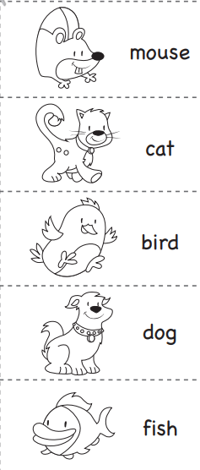
Colour the animal you teacher says.

